**FREE GOODS CHARGEBACK SET UP**

**Marketing Promotions will have to provide the HS codes for free goods chargeback upload**

**When we have the list we can start entering on the Free Goods template upload**

**On template enter the External Contract Number, Description, USER ID, Contract start/end dates, list all HS codes for one vendor, Percentage off-enter 99.99 on line item not header**

**Click Send and with assigned upload number should be uploaded**

**Page1**

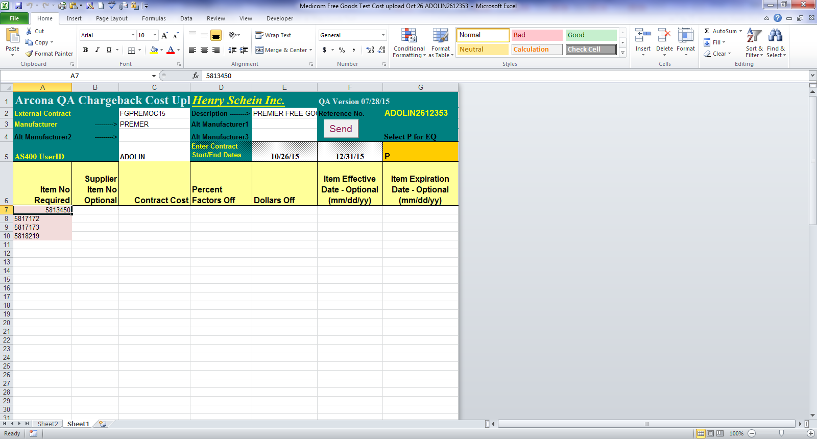

**Go to the JDE Contract screen and pick**

**6-Upload Administration**

**Look for vendor and upload performed and enter 5 to upload with new contract number**

**Page 2**

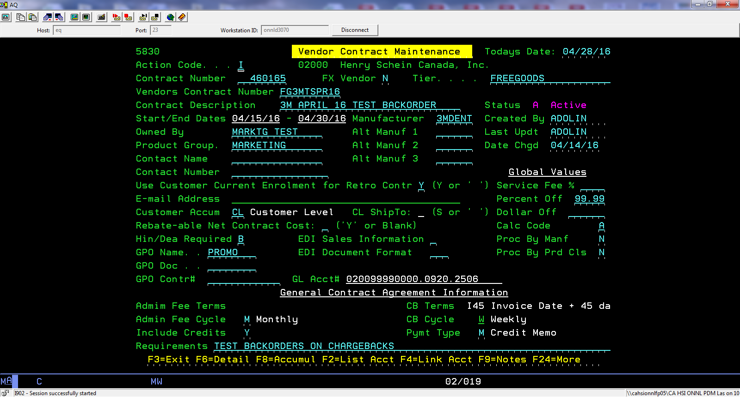

You will have to add information as per regular chargebacks

Difference with free goods are-

TIER- FREE GOODS

CUSTOMER LEVEL – CL –no numbers to upload

Cal Code- should be A for percent off cost

In the GPO NAME – enter PROMO

Requirements enter if room the free goods deals

Page 3